Wildfire Smoke Toolkit
California Area Indian Health Service
June 2024

Table of Contents

Introduction
Health Impacts
- Symptoms of Wildfire Smoke Exposure
  - General Population
  - Sensitive Groups
- Extreme Heat and Wildfire Smoke
Air Quality Index
Sources of Air Quality Information
- Local Air Quality Management District
- AirNow
- Interagency Wildland Fire Air Quality Response Program
- PurpleAir
- California Smoke Spotter App
Strategies to Reduce Wildfire Smoke Exposure
- At Home
- N95 Respirators
- Specific Strategies for Sensitive Groups
- Specific Strategies for General Population
Preparing for Wildfire Smoke
- Have a Plan
- Maintain a supply of N95 Respirators
- Portable HEPA Air Purifier
- MERV 13 HVAC Filters
- Eliminate Smoke Entry Points
References
Appendices
- Appendix A: Training/ Instructional Videos
- Appendix B: Guides and Templates

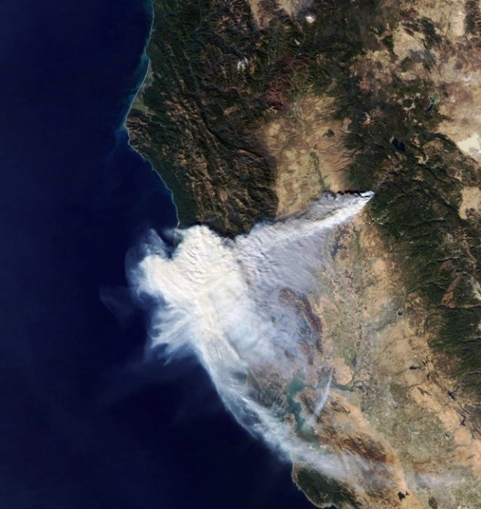
Photo showing smoke from Camp Fire in 2018 causing poor air quality along the CA coast.
Source: https://www.epa.gov/wildfire-smoke-course/challenges-predicting-smoke-concentrations

Introduction
Cal Fire has reported over 6,115 wildfires in California that have burned a total of 318,373 acres, in 2023. The largest fire in California history was the August Complex fire which burned across seven counties with a total burn area of 1,032,64 acres, in 2020¹. Wildfires are not only an immediate threat for people, infrastructure, and buildings in close proximity to the fire, but also the smoke produced from these fires can have public health impacts hundreds of miles away. The broad reach of wildfire smoke along with the many factors that affect how the smoke moves, such as ambient temperatures, terrain, and wind direction/intensity, makes it difficult to predict when and where wildfire smoke will be present². It is for this reason that every Californian should be prepared for wildfire smoke.
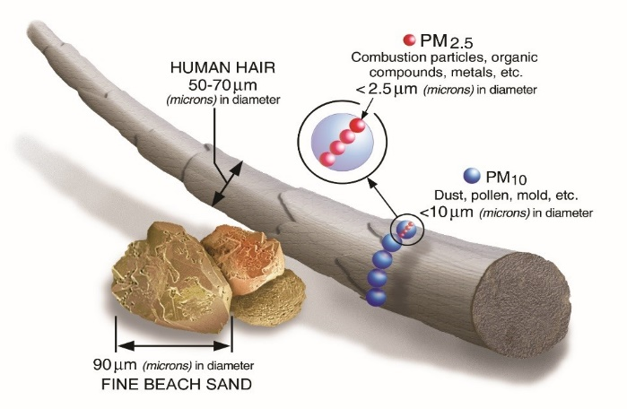
Chart comparing the size of particulate matter to sand and human hair.
Source: https://www.epa.gov/wildfire-smoke-course/why-wildfire-smoke-health-concern

Wildfire smoke is a mix of small particles, gases, vapors, and water. The components of wildfire smoke that are the major public health concern are particulate matter (PM), which are small particles that are grouped based on their size. Larger particles between 2.5 and 10 micrometers are categorized as PM 10 and particles smaller than 2.5 micrometers are categorized as 2.5 micrometers. PM 10 particles are too large to penetrate into the lungs and mainly cause eye, nose, and throat irritation. However, PM 2.5 particles are small enough to penetrate deep into the lungs and impair lung function. These particles may also enter the bloodstream and contribute to plaque formation in the blood vessels and heart. This damage to your lungs and heart can make breathing more difficult and can have serious negative health effects, especially if you have pre-existing conditions³. This toolkit was developed to help guide your decision making to become better prepared for wildfire smoke and help prevent serious illness.

Health Impacts
Wildfire smoke affects everyone differently and depends largely on age, pre-existing conditions, smoke levels present in the community, levels of activity and how long the person is exposed. People who are considered sensitive may have more severe symptoms when compared to those who are not. Sensitive groups would include children younger than 18 years old, people with pre-existing heart/lung conditions like asthma or Chronic Obstructive Pulmonary Disease (COPD), people 65 and older, and pregnant women. Some studies have found that there are long term effects from prolonged or repeated wildfire smoke exposure including: reduced lung function, chronic bronchitis, and premature death⁴.
  - Symptoms of short term wildfire smoke exposure (hours to days) for those not sensitive may include:
- Coughing | - Runny Nose | - Trouble Breathing
- Wheezing | - Sinus Irritation | - Headache
- Increased Heart Rate | - Tiredness | - Eye Irritation (Watering/Itchy/Stinging)
- Chest Pain | - Throat Irritation

  - Symptoms of short term wildfire smoke exposure for sensitive groups may include the above listed, but also:
- Aggravated Lung Disease | - Asthma Attack | - Acute Bronchitis
- Heart Attack | - Heart Arrhythmia | - Stroke

Excessive Heat and Wildfire Smoke Exposure
Extreme heat exposure can have similar symptoms to wildfire smoke exposure and researchers have found that when you are exposed to both at the same time, there is a combined effect that increases your risk of severe illness. A study done in 2022 found that there was an increased risk for severe illness caused by the combination of excessive heat and wildfire smoke by as much as 21%, which was largely seen in patients over 75 years old⁶. Another study found that 42% of Californians were exposed to a combination of extreme heat and PM 2.5, with rural Californians being the most affected⁷. The National Weather Service will issue Excessive Heat Advisories, Watches, and Warnings so it is recommended to routinely check the National Weather Service website during the summer months, especially when wildfire smoke is present (Link: National Weather Service).
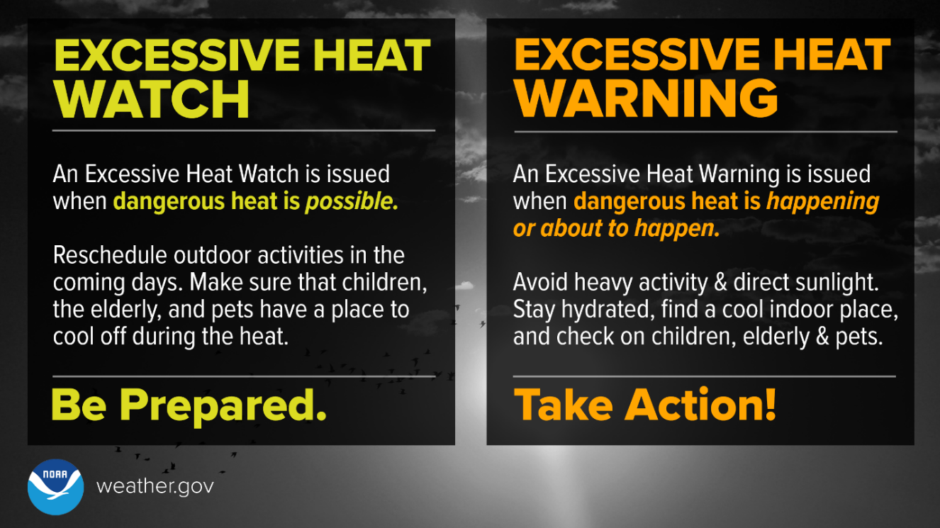

Air Quality Index (AQI)
The Air Quality Index (AQI) is a tool developed by the U.S. Environmental Protection Agency (EPA) to report air quality information in an easy-to-understand format. The EPA monitors 5 major air pollutants including Ozone, Particle Pollution (PM 2.5 and 10), Carbon Monoxide, Sulfur Dioxide, and Nitrogen Dioxide and each contributes to the AQI. The AQI ranges from 0 to 301+ and is broken down into 6 different categories based on levels of risk for health impacts.
Air quality below 100 is generally considered good to acceptable for most people, however above 100, the AQI becomes unsafe for sensitive groups and eventually affects everyone as the AQI increases⁵. This chart should be referenced when monitoring local air quality information.
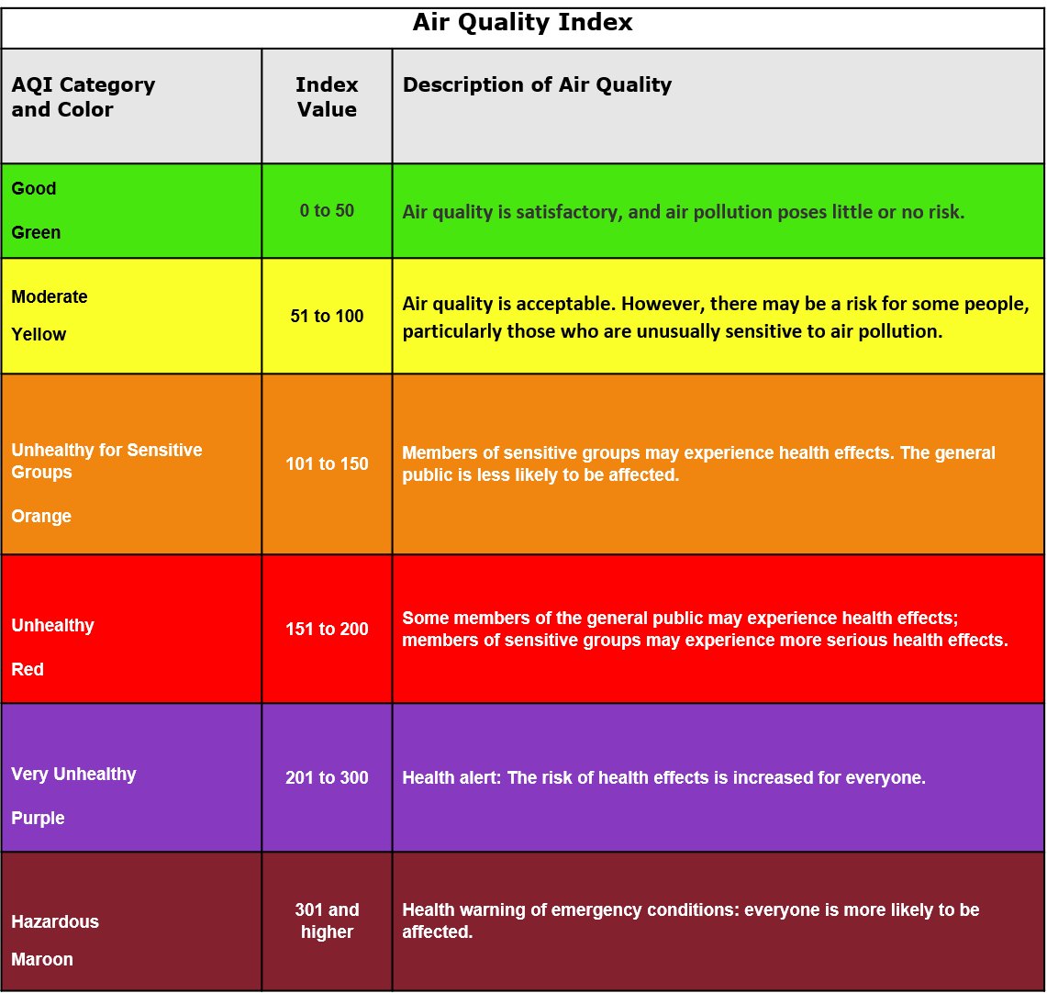

Sources of Air Quality Information
The best source of air quality information is your local Air Quality Management District. The California Air Resources Board has a list of 35 local Air Districts that can be found here: https://ww2.arb.ca.gov/california-air-districts.
Tribes may also monitor air quality and report more specific (local) air quality information. Check with your Tribe’s Land Management, Environmental, or Emergency Services Department to see if they are providing this information. During wildfire season air quality information may be provided by your Tribe’s Office of Emergency Services on their social media sites, such as Twitter, Facebook, or Instagram. Additional resources for air quality information follows.
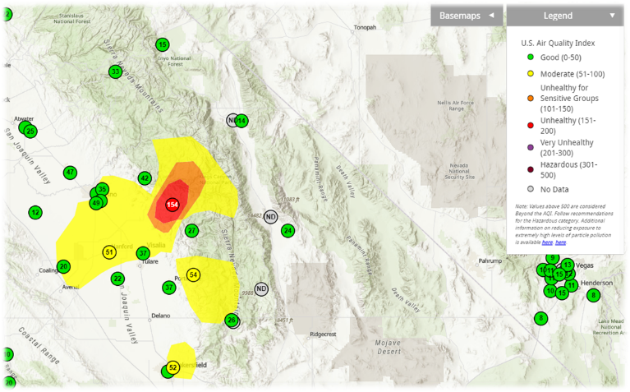
Example of the AQI map found at the AirNow real-time map.
Source: airnow.gov
- Fire.airnow.gov
You can search for specific air quality information by typing your zip code into the search bar on this webpage. The Fire and Smoke Map shows information on particle pollution, fires, and smoke plumes.
- Interagency Wildland Fire Air Quality Response Program (IWFAQRP)
Provides regional air quality information as well as a 72-hour forecast for specific municipalities within that region. The reports also provide information about local wildfires and links to more information regarding wildfire safety. When a report for your region is available it will be a square that you can click on, and it will take you to the IWFAQRP report.

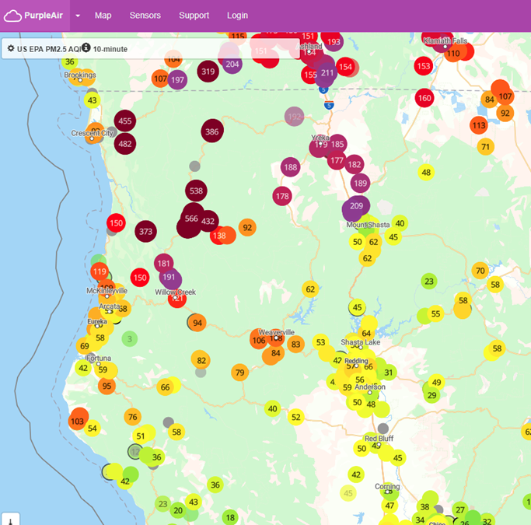
Example of the PurpleAir Real-Time AQI map.
Source: map.purpleair.com
- PurpleAir Real-time Air Quality Monitoring Maps
PurpleAir is another popular source of air quality information, however it recommended to use the information from this website with caution. Purple Air sensors are fairly accurate when AQI is below 150, however when the particulate matter AQI is higher than 150, the sensors lose accuracy and corrections are needed. Fire.AirNow.gov actually uses the data from these sensors and applies the corrections when the AQI is above 150. It is therefore recommended to use Fire.AirNow.gov when AQI is being reported above 150 for your area.

- Cell Phone App: California Smoke Spotter
This App provides 72-hour smoke forecasts as well as alerts for wildfires and prescribed burns in your area. You can tag multiple locations in case you have family members in other areas or are planning travel. The app also shows you which Air Quality Management District you reside in and also allows you to switch between AirNow and PurpleAir air quality data.

Strategies to Reduce Smoke Exposure

When smoke is present, reduce your exposure at home by:
- Closing all windows and doors that would allow smoke into your home.
- If you have air conditioning, ensure you set it to recirculate mode so that it is not bringing in outside air.
- If you have a window mounted air conditioning unit, you should close the outdoor air damper.
  - If your unit doesn’t allow you to do that, it is recommended not to use it to avoid bringing in outside air.
- Avoid using evaporative coolers or “swamp cooler” as those pull unfiltered outdoor air into the home.
- Use a HEPA Air Purifier sized appropriately for the room it is used in.
- Avoid adding indoor air pollutants such as:
  - Smoking
  - Using gas, propane, or wood burning stoves
  - Spraying aerosols, like air fresheners
  - Frying or broiling
  - Vacuuming
  - Burning candles/incense/sage
- If you cannot avoid wildfire smoke in your home, go to a local cleaner air facility or cooling center. Other public locations for respite from wildfire smoke may include your local mall, library, community center and senior center. Call your local Office of Emergency Services or Tribal Health Program to get information on local clean air facilities.
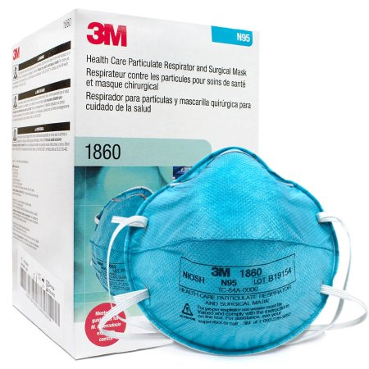
3M N95 Respirator Model 1860
If you must go outside while wildfire smoke is present, wear a NIOSH approved N95 Respirator.

If you have a health condition that makes you sensitive to wildfire smoke, speak to your healthcare provider about wearing an N95 or P100 respirator before you do so. Dust masks, surgical masks, or cloth face coverings should not be used as a substitute for an N95 or P100 respirator as they do not have the necessary filtering capabilities or will not produce a snug fit that is needed to keep PM 2.5 particles from entering your lungs when you breathe. See the Preparing for Wildfire Smoke section for information on how to properly select and wear an N95 respirator.
AQI Level | Recommended Action for Sensitive Groups
51-100 (YELLOW) | Unusually sensitive people should monitor symptoms and consider reducing outdoor physical activity
101-150 (ORANGE) | Reduce outdoor activity, monitor symptoms.  People with asthma should follow their asthma action plan.  People with heart disease should watch for fatigue, palpitations, or shortness of breath. If present, call your healthcare provider.
151-200 (RED) | In addition to above listed,  Avoid heavy exertion and spend more time indoors.  Keep windows and doors closed at home.  Use AC in recirculate mode (car and home)  Avoid operating window fans.
201-300 (PURPLE) | In addition to above listed,  Avoid all outdoor physical activity.  Avoid generating indoor pollutants (burning candles, frying/broiling food, spraying air fresheners, wood fireplaces, vacuuming)
300+ (MAROON) | In addition to above listed,  Stay indoors and maintain low activity levels.  Have someone check on you or assist with essential outdoor activities.  If you must go outside wear an N95 or P100 respirator if your doctor says it is okay for you to do so.  Use a portable air cleaner (HEPA air purifier) at home

AQI Level | Recommended Actions for General Population
51-100 (YELLOW) | Okay
101-150 (ORANGE) | Usually okay but monitor for symptoms. If symptoms worsen, consider reducing activity or spending time indoors.
151-200 (RED) | Reduce outdoor heavy exertion.  Keep windows and doors closed at home.  Use AC in recirculate mode (car and home)  Avoid operating window fans.
201-300 (PURPLE) | Avoid outdoor heavy exertion.  Avoid generating indoor pollutants (burning candles, frying/broiling food, spraying air fresheners, wood fireplaces, vacuuming)
300+ (MAROON) | In addition to the above listed,  Stay indoors; only go outside for essential activities and wear an N95 or P100 respirator.  Use a portable air cleaner (HEPA air purifier) at home

Preparing for Wildfire Smoke
- Have a Plan
- If you or your child has asthma, work with your healthcare provider to develop an Asthma Action Plan.
- If you are considered Sensitive to wildfire smoke, have a plan to leave the area, stay with a friend or family member, or stay at a cleaner air facility during peak smoke levels.
  - Know ahead of time where cleaner air facilities will be located. Your Tribal Health Program or Tribal Office of Emergency Services will be able to tell you the usual locations.
- Keep a supply of your medications that will last at least 7 days in case you need to evacuate or stay at a shelter.
- Plan to create a Clean Air Space in your home when the AQI is Unhealthy.
  - Pick a room that fits everyone in your family comfortably.
  - This room would preferably have an attached bathroom and be able to support a portable HEPA air purifier that is correctly sized for the room.
  - The following guidance will help you reduce wildfire smoke inside your home and should be considered when planning your Clean Air Space.
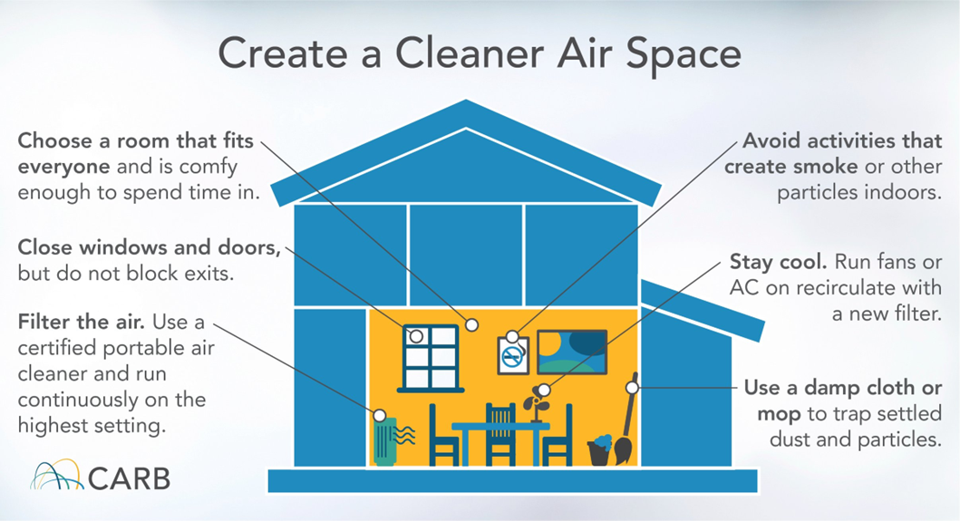
- Have a Supply of N95 Respirators and Ensure They Fit Properly
- Have at least one box of 20 respirators per adult in your household for each fire season.
  - It is not recommended to put an N95 on young children as they are not designed for their size and may not produce a proper fit. It is recommended to keep young children indoors when wildfire smoke is present.
  - N95 respirators can be reused for wildfire smoke as long as they are not heavily soiled or damaged.
- Ensure that the N95 has a label stating that it is NIOSH approved.
  - NIOSH approved respirators are tested to ensure that they filter out at least 95% of airborne particles.
  - A list of NIOSH approved N95 respirator manufacturers can be found here: NIOSH Approved N95s
- Ensure that the N95 you are planning on using fits properly.
  - If you have a health condition that would make you sensitive to wildfire smoke, talk to your healthcare provider before wearing an N95 respirator.
  - N95 respirators have two straps that go around your head (one above and one below your ears) and have a bar over the nose that you pinch to create a seal around the bridge of your nose.
  - The mask should fit snuggly against your face and should pull tighter to your face as you breathe in air.
  - A beard or other facial hair will prevent a proper seal around your face, meaning the air you breathe is not being properly filtered. Consider shaving if planning to wear an N95 for protection from wildfire smoke.
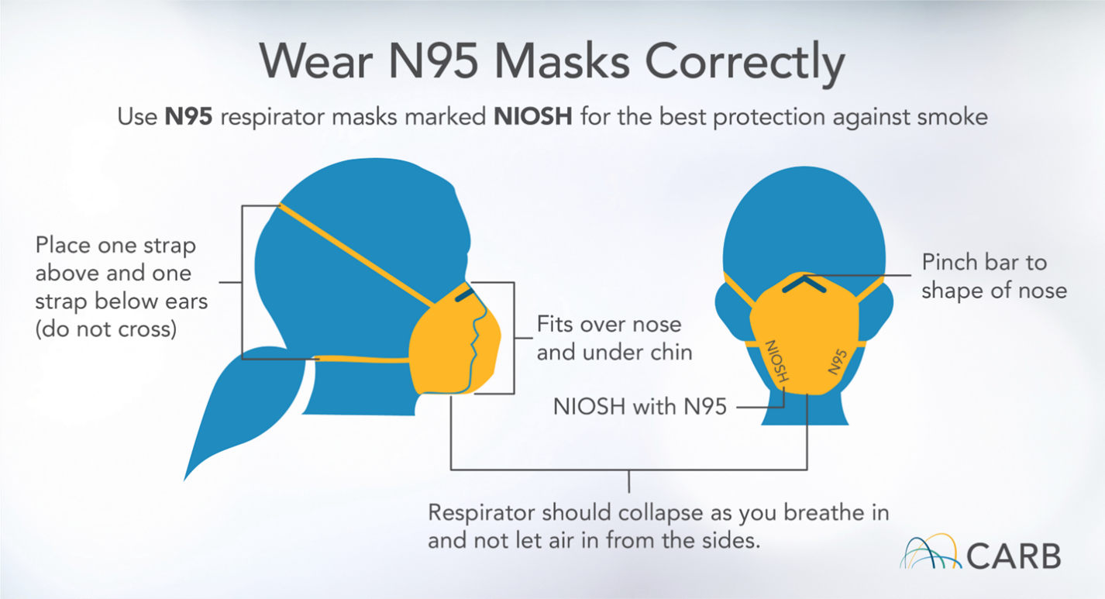
- Dust masks, surgical masks, cloth face covering, or a mask with air vents should not be used as a substitute for an N95, as they do not have the filtering capabilities to remove PM 2.5 from the air you are breathing.
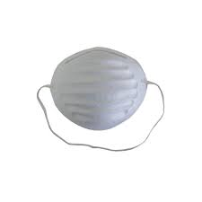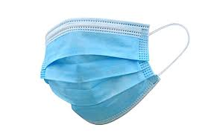√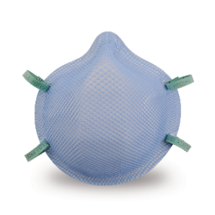

- Acquire a Portable HEPA Air Purifier
- Consider purchasing your air purifier well before fire season as availability may be limited during peak wildfire smoke season.
- Choose your air purifier based on the square footage of the room where it will be used.
  - Air purifiers will have a specific square footage that they are designed for, and this square footage specification varies based on make/model.
  - If you do not know the size of your room, measure the length and width to calculate the square footage. If you cannot directly measure it, the average bedroom size is 132 square feet and up to 220 square feet for master bedrooms⁸.
- Choose a HEPA air purifier that is California Air Resources Board (CARB) certified.
  - CARB certification shows that the air purifier meets electrical safety and ozone emission standards⁹.
  - CARB certified HEPA Air Purifiers can be found here: CARB Certified Air Cleaning Devices List
- Place the portable HEPA air purifier:
  - In the rooms where your family spends most of their time or where it is needed most (such as an area where wildfire smoke cannot be kept outside of the home).
  - Away from windows, doors, and foot traffic.
  - Avoid placing it next to walls and corners as this will reduce the effectiveness of the air purifier.
- Maintain a supply of replacement filters.
- Check with the manufacturer’s recommendations for changing the filters on your device. 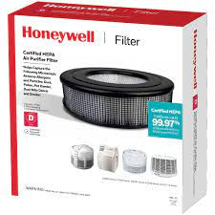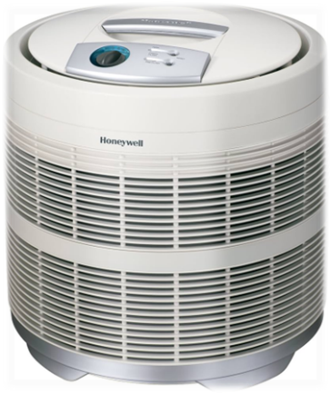
- If you cannot purchase a manufactured air purifier, you can build one yourself: Be sure to read the manufacturer’s instructions for your specific box fan, as some models advise not covering the grill. 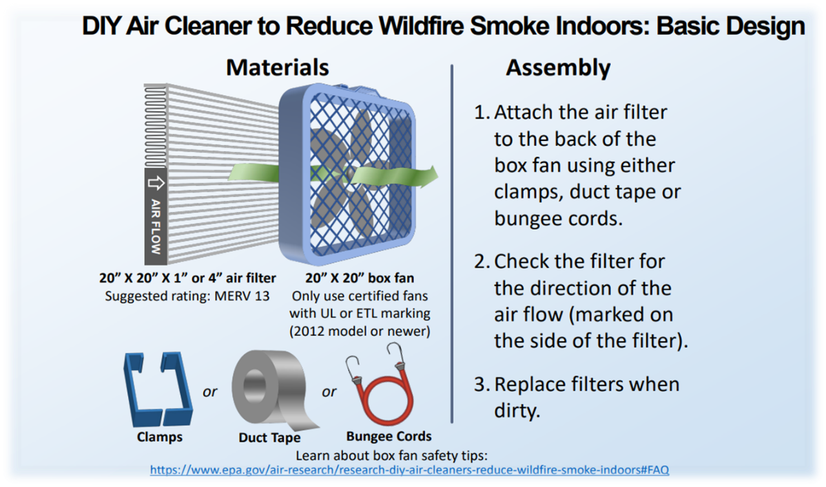

- Install a MERV 13 or Higher Filter on Your Home Air Conditioning System
- Check with the manufacturer of your HVAC system to see if it can handle a MERV 13 filter. If you still are not sure, reach out to an HVAC professional to assess your system.
- Keep a supply of replacement filters and replace your filter according to the manufacturers recommendations or when the filters appear heavily soiled. (During heavy smoke, filters may need to be changed more frequently to avoid overloading your HVAC system).

- Assess Your Home for Smoke Entry Points
- Repair any broken seals or cracks around windows and doors.
- Close your fireplace damper to prevent smoke from coming in through the chimney.

Indian Health Service
Office of Environmental Health and Engineering Links

OEHE Services:
CA AREA OEHS Services Brochure

CA AREA DEHS Services and Contact Information:
CA Area DEHS Services Page
References
- “Statistics.” Cal FIRE, www.fire.ca.gov/our-impact/statistics. Accessed 16 May 2024.

- “Challenges Predicting Smoke Concentrations.” EPA, Environmental Protection Agency, www.epa.gov/wildfire-smoke-course/challenges-predicting-smoke-concentrations. Accessed 16 May 2024.

- “Why Wildfire Smoke Is a Health Concern.” EPA, Environmental Protection Agency, www.epa.gov/wildfire-smoke-course/about-wildfire-smoke-course. Accessed 16 May 2024.

- EPA. Particle Pollution and Your Health, nepis.epa.gov/Exe/ZyPDF.cgi/P100RQ5N.PDF?Dockey=P100RQ5N.PDF. Accessed 16 May 2024.

- EPA. “Wildfire Smoke and Your Patients Health.” Wildfire Smoke Course, Environmental Protection Agency, www.epa.gov/wildfire-smoke-course/wildfire-smoke-and-your-patients-health-air-quality-index. Accessed 16 May 2024.

- Rahman, Md Mostafijur, et al. “The Effects of Coexposure to Extremes of Heat and Particulate Air Pollution on Mortality in California: Implications for Climate Change.” American Journal of Respiratory and Critical Care Medicine, U.S. National Library of Medicine, 1 Nov. 2022, www.ncbi.nlm.nih.gov/pmc/articles/PMC9704834/.

- Novoselov, Anna. “Dangerous Combination of Extreme Heat and Smoke Affected 16.5 Million Californians.” UCLA, UCLA, 15 Aug. 2023, newsroom.ucla.edu/releases/heat-and-smoke-combo-affects-millions-of-californians.

- Lephare. “Standard Bedroom and Master Bedroom Average Bedroom Sizes.” Cedreo, Cedreo, 10 May 2023, cedreo.com/blog/average-bedroom-size/.

- “List of Carb-Certified Air Cleaning Devices.” List of CARB-Certified Air Cleaning Devices, ww2.arb.ca.gov/list-carb-certified-air-cleaning-devices. Accessed 16 May 2024.

Appendix A: Training and Instructional Videos
How to Put on an N95 Video Link: CDC Put on N95 Respirator
How to Build a DIY Box Fan: How to build a box fan HEPA filter

Appendix B: Guides and Templates
EPA Guide to Air Cleaners in the Home: 2nd Edition: Portable Air Cleaners, Furnace and HVAC Filters

